💧 Jal Rekha – Sopan Module User Manual
Madhya Pradesh Jal Nigam Department

🔹 Introduction
The Sopan module is designed to streamline the process of capturing and monitoring the contractor’s commitment date for the completion for different components like Intake well, WTP, Overhead Tanks (OHTs),IPS . This guide will walk you through the login process and the initial navigation steps for contractors.

🔹 1. Accessing the Login Page
Step 1: Open your web browser and navigate to the official Jal Rekha Portal.
Step 2: On the login page, you will see fields to enter:
- User Name: Enter your registered mobile number or username provided by the department.
- Password: Enter your secure password.
- Captcha: Enter the displayed security code to verify you are a genuine user.
Step 3: Check the box to agree to the Terms & Conditions.
Step 4: Click the Login button.
If you forget your password, use the Forgot Password link to reset it.

🔹 2. Contractor Dashboard Overview
Once logged in, you will land on the Contractor Dashboard — the main workspace for managing your commitments and work progress.
On the left-hand side of the screen, the navigation menu provides access to various modules:

💡 Menu Sections:
- User Management:
- Anushravan:
- Master:
- Sopan Module:
This is the three options:
  - Work Monitoring – To enter the Planned and Actual Dates.
  - Mapped OHTs – Contractor can check the OHTs mapped under asset mapping.
  - Show Work Monitoring Details – All submitted OHTs details can view through this option.

🔹 3. Logging Out
After completing your updates or viewing the necessary information:
Step 1: Click on the Logout button located at the bottom left of the sidebar.
Step 2: You will be securely logged out of the portal.

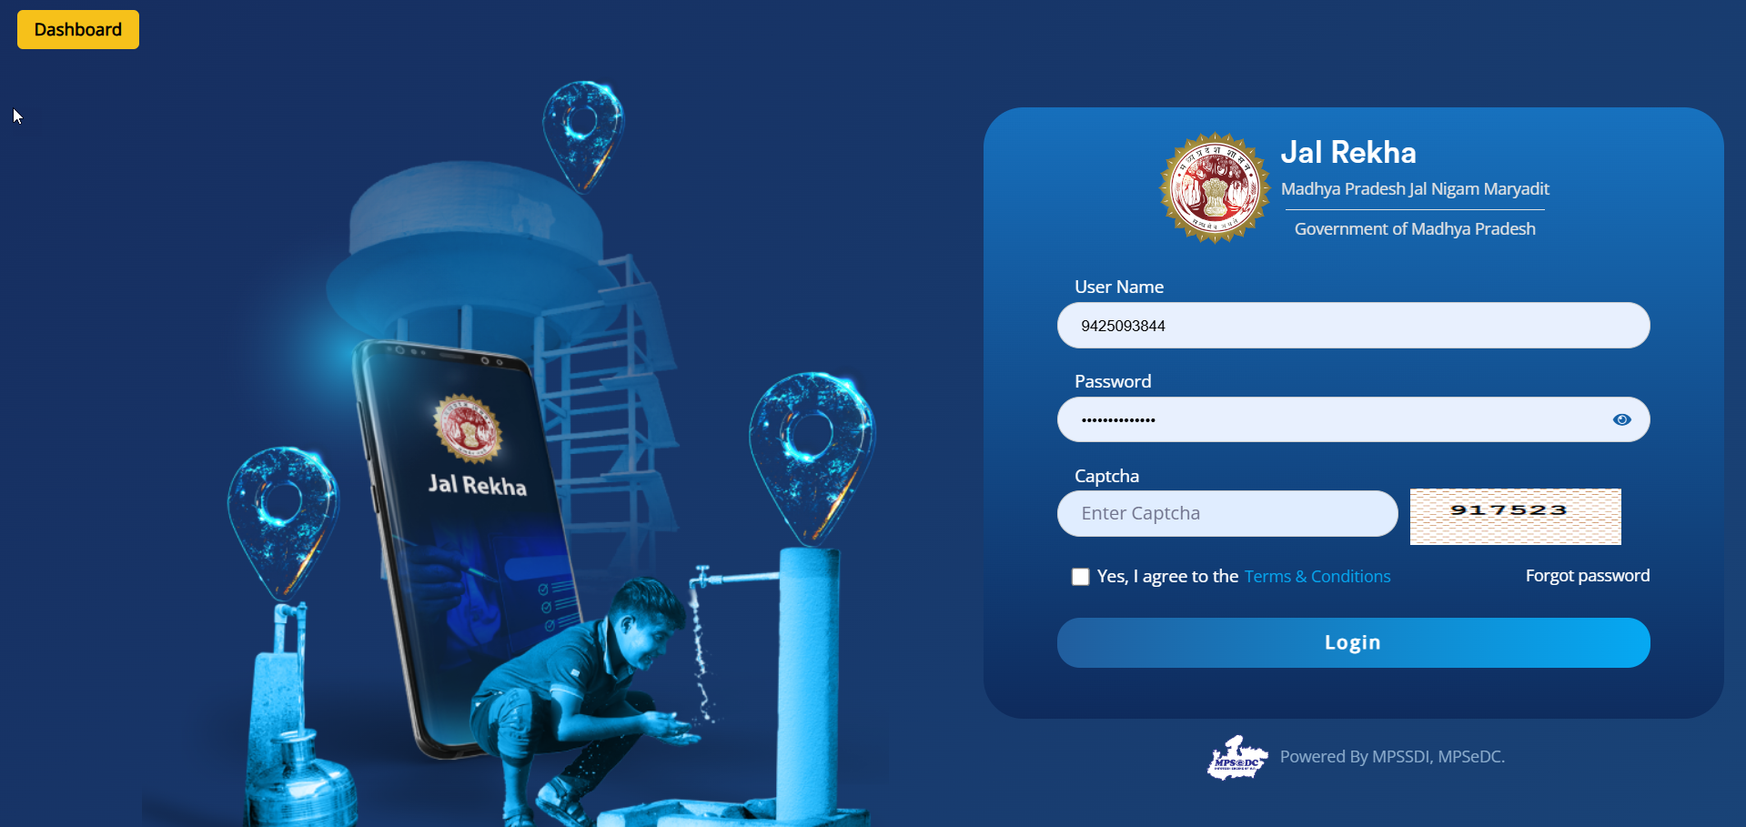

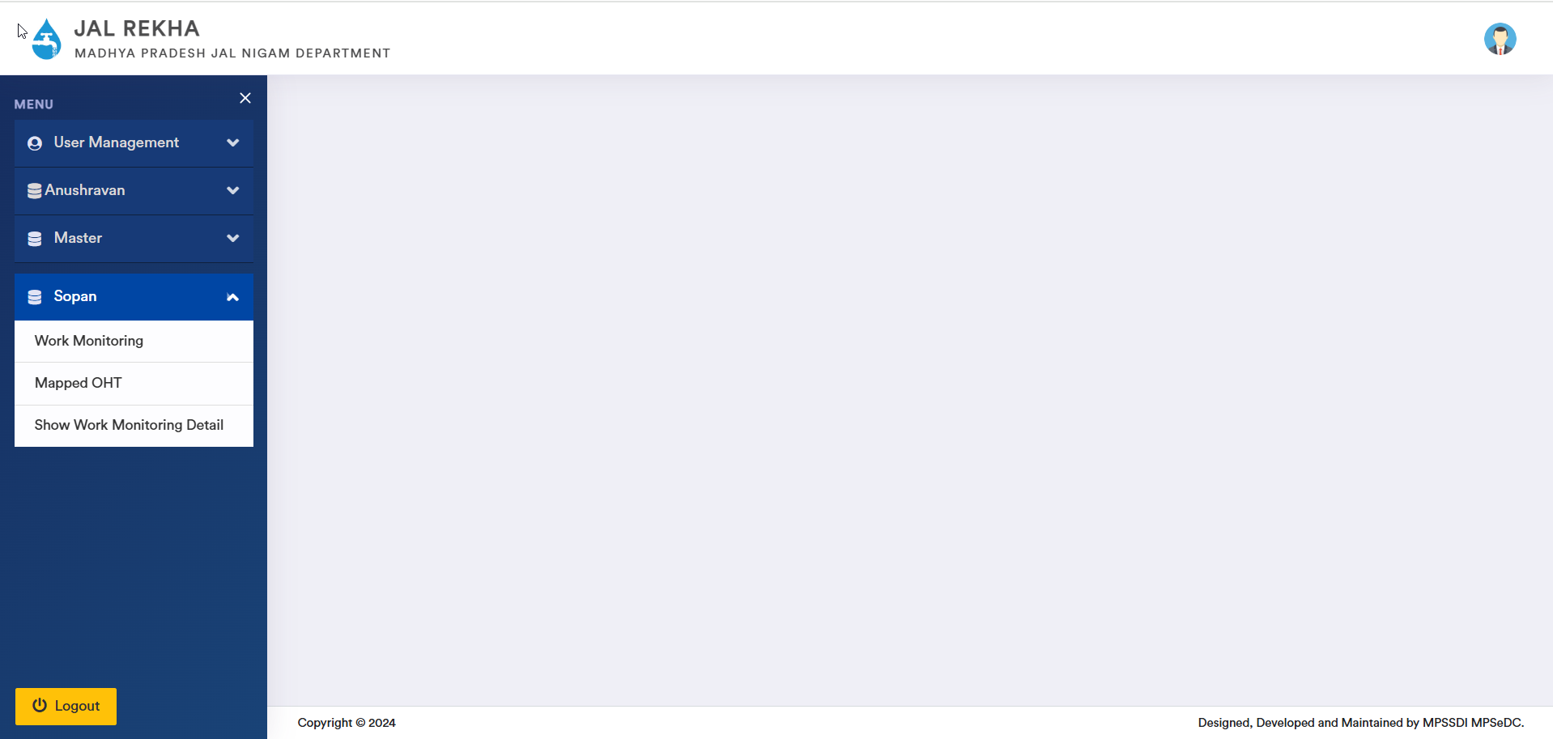

Step-by-Step: How to Use the Work Monitoring Screen

1️⃣ Select Your Scheme and OHT
At the top of the page:
- Scheme Dropdown: Choose the relevant water supply scheme from the dropdown list (Example: Arniya Bahadur Multi Village Rural Water Supply Scheme).
- OHT Dropdown: Select the specific OHT that you're updating (Example: Asadi (OHT-004-2)).

2️⃣ Update Construction Stages
For each Stage of Construction listed (from preliminary site preparation to the final commissioning), fill in the following:
- Status:
Choose the current status of the stage (Not Started / In Progress / Completed).
- Planned Start Date & Planned End Date:
Select the original planned schedule for the work.
- Actual Start Date & Actual End Date:
Enter the actual dates when the work started and finished.
- Delay (Days):
This field will automatically show the difference (if any) between the planned and actual end date.
- Remark:
Add any relevant notes, such as reasons for delay, site issues, weather conditions, or inspection observations.

3️⃣ Navigating Multiple Entries
- If the list is long, scroll horizontally using the arrow buttons on the top right side of the table to move through the data smoothly.

4️⃣ Saving Your Updates
Once you have completed all entries:
- Click Save (blue button) to confirm and submit the updates.
- Click Reset (red button) to clear the form and start fresh.

⚠️ Important Tips
- Make sure to update this screen regularly — especially after each construction milestone.
- Always enter real dates to avoid project discrepancies.
- Use the remark field to justify any delays or issues.

